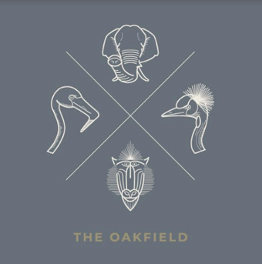

Starters & Sharers

Pea and ham hock veloute, multiseed cob & English butter 5.50 (*)
Runny Scotch egg, wye valley asparagus & mushroom marmalade 6.50
Crispy Whitebait, smoked paprika, Anchovy aioli 6.50
Sesame & satay chicken wings, Asian salad 6.75 (gf)
Crispy Goats cheese crottin, red wine poached pear, candied walnuts 7.50 (v)
Prawn cocktail with crushed avocado, sourdough toasts 9.95 (*)
A selection of local cheese, quince jelly, Bath Oliver, oatcakes & pickled grapes 12.95

The Oakfield Ploughmen’s Platter
Scotch egg, chipolatas, pork pie, Appleby’s Cheshire cheese, pickles, apple slaw, crunchy sour dough, smoked mushroom marmalade 15.95

The Oakfield Charcuterie Platter
A selection of cured meats, olives, artichokes, stuffed peppers, hazelnut cream, toasted hazelnuts, sea salt & rosemary focaccia (*) 17.95

Mains
Pork & leek sausage ring, creamed potato, buttered leeks & onion gravy 10.25
Tempura North Sea haddock, Cheshire farm chips, mushy peas and tartar sauce 12.95
Giant North Sea Haddock, Cheshire farm chips, mushy peas and tartar sauce bread & butter 16.95
8oz Steak burger, bacon and cheese, tomato relish, Cheshire farm chips 13.50
Molasses baked Ham, fried eggs, Cheshire farm chips and piccalilli 10.95 (gf)
4oz rump steak, toasted ciabatta, caramelised onions and mustard aioli 10.95 (*)
Chicken & ham pie, champ potato, mushy peas & tarragon jus 14.50
Caesar salad, romaine lettuce, smoked bacon, sourdough, soft hen’s egg, anchovy and parmesan 12.50
Add chicken 14.50 (*)
Cod Nicoise, cured tomato, green beans, Cheshire potatoes, soft egg and black olive tapenade 16.75 (gf)

Sides
Cheshire farm chunky chips 3.95 (gf)
Garlic ciabatta with cheese 4.50
Fine beans, blush tomato & shallots 3.95
Cheshire potatoes, spring onion & shallot 3.95
French fries 3.95
Buttered carrots 4.00 (gf)

Puddings
Baileys cheese cake, iced honeycomb and fresh berries 5.95
Eton berry mess 6.25 (gf)
Banoffee mess 6.25 (gf)
Vanilla burnt cream, almond shortbread 5.95
Sticky chocolate pudding, bitter chocolate sauce 6.25

